**Overview of digitally available observations of the Dutch Antilles and Surinam at KNMI**

10 juli 2024

|  |  |  |  |  |
| --- | --- | --- | --- | --- |
| Land | Station | Period | Frequency | Variables |
| Aruba | Oranjestad | 1920, 1927-1938 | 1/d | P, Rd |
| Aruba | Oranjestad | 1936-1940** | 3/d | DD, FF, N, RH, T, Tw, P, Rd*, Tn*, Tx* |
| Bonaire | Kralendijk, Rincon+, Plantage Bolivia+ | 1920, 1927-1941 | 2/d | P, T, Rd* |
| Curaçao | Willemstad | 1898/08- 1903/11 | 24/d | FF |
| Curaçao | Willemstad | 1902-1920++ | 1/d | DD, FF, T, P, Rd, Tn, Tx |
| Curaçao | Willemstad*** | 1910-1946 | 3/d | DD, FF, N, RH****, T, Tw, P, Rd*, Tn*, Tx* |
| Saba | The Bottom, Sint Johns+, Windwardside+ | 1920, 1927-1943/08 | 3/d (1920 2/d) | T, P, Rd* |
| St. Eustatius | Proeftuin Concordia | 1943-1946$ | 3/d | P, Rd* |
| Surinam | Paramaribo | 1896-1962 | 3/d | DD, FF, T, P, Rd*, Tn*, Tx* |

*Once a day

**The number of variables included in this period slowly increases to all variables in 1940

***Available as (Latin-1 encoded) TXT files with little information. Decimals are excluded, meaning T, EE, Tw, Pt, Tn and Tx need to be divided by 10. The division needed for Rd is unclear; dividing by 10 gives normal values before 1922, but results in extreme rainfall from 1922 (many events of >100 mm, some of >500 mm). Dividing by 100 gives normal values after 1922, but results in measurements to two decimals, which seems unlikely.

****Encoded as “U” in the files.

+Only rainfall amount (Plantage ‘Bolivia’ only from 1935 onwards).

++Variables vary across the period. Till about 1918 the there are no measurements in the period half November to the end of June.

$Air pressure is missing in some years

**Variables**

DD Wind direction

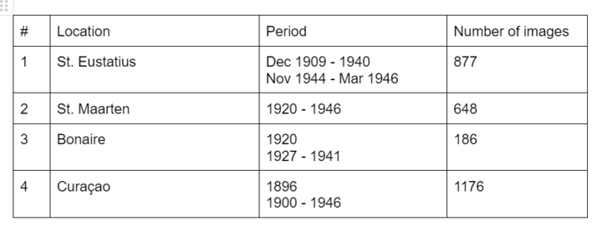FF Wind speed

N Cloudiness

RH Relative humidity

T Temperature

Tw Wet bulb temperature

P Air pressure

EE Vapor pressure (?)

Rd Rainfall amount

Tn Minimum temperature

Tx Maximum temperature

*Images scanned in the innovation weeks*